Geometry: Unit 3, Lesson 4
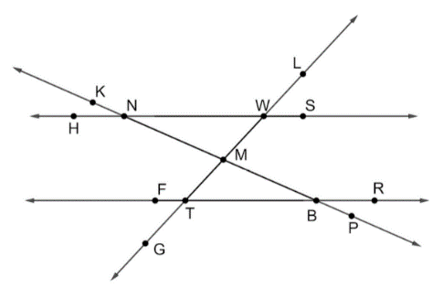
- Lines $HS$, $FR$, $GL$, and $KP$ are shown. $\overset{⃡}{HS}∥\overset{⃡}{FR}$ with $\overset{⃡}{KP}$ and $\overset{⃡}{GL}$ as traversals. What type of angles are $∠NMW$ and $∠TMB$

Vertical angles

- $∠THR$ and $∠BLZ$ are alternate interior angles. If $m∠THR=\left(2x-6\right)°$ and $m∠BLZ=\left(7x-9\right)°$, what is the value of $x$?

$$x=\frac{3}{5}$$

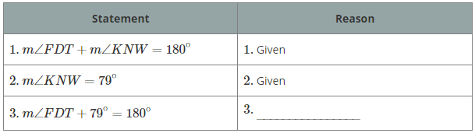
- An incomplete proof is shown. What is the reason for statement 3?

Given: $m∠FDT+m∠KNW=180°$ and $m∠KNW=79°$
Prove: $m∠FDT+79°=180°$

Substitution property of equality

